G1ANT RPA INTERNSHIP 2020



PROJECT: TRAVEL ARRANGEMENT

WEBSITES USED : [WWW.Goibibo.COM,](http://www.yatra.com/) WWW.MakeMyTrip.COM

SOFTWARE : VISUAL STUDIO, G1ANT RPA

PROJECT CONTRIBUTORS

Sanskar Gupta

Dhruv Sharma

PROJECT LEAD

Mr. KUMAR NALINAKSH

Asia Pacific Community Lead

# TRAVEL ARRANGEMENT

Description

With most business trips, at least a portion of the time that is spent at the destination will be thoroughly scheduled. For example, a traveller may be attending a conference or convention, or he or she may have numerous meetings with different people across town planned. Everything from the location of the hotel to the flight times that are selected should be based around the schedule, so it is important to develop this schedule before making travel arrangements. The process of the code is to simulate a real-time process automation strategy in supporting Tour & Travel Arrangement. In this project we developed code using selenium commands, google docs commands. This code is made for[www.Goibibo.com](http://www.Goibibo.com)[,](http://www.yatra.com/)[www.MakeMyTrip.com](http://www.MakeMyTrip.com)[.](http://www.ixigo.com/) We also created an add-on for [Goibibo.com](http://yatra.com/) for complete automation of the site using Visual Studio 19 and G1ant SDK. In this coding we have made it easier for the people to books ticket from any means of transport so that they will be easily do it.

Google sheet link:-

In this sheet we are going to store the data of the candidate who is travelling.

https://docs.google.com/spreadsheets/d/1uwr_5CkxrrhCPEMzJl18HL1WQHPM6H6Vn2s9ob_CDEY/edit?usp=sharing

Spreadsheet ID:-

1uwr_5CkxrrhCPEMzJl18HL1WQHPM6H6Vn2s9ob_CDEY

|  |  |  |  |  |
| --- | --- | --- | --- | --- |
| Argument | Type | Required | Default Value | Description |
| type | Text | Yes |  | Enter the default browser for opening the webpage [Chrome,  Firefox] |

|  |  |  |  |  |
| --- | --- | --- | --- | --- |
| email | Text | Yes |  | Enter the operator’s email here |
| pword | Text | Yes |  | Enter the operator’s password here |
| to | Text | Yes |  | Enter the email  of the user to whom the message is to be sent |
| subject | Text | Yes |  | Enter the title of the message |
| message | Text | Yes |  | Draft your email |
| Id | Text | Yes |  | Opens up the required google spreadsheet with the required id for  performing operations |
| result | Text | No | result | Name of a variable where  the command's result will be stored |
| if | Bool | No | true | Executes the command if the expected condition is true |

|  |  |  |  |  |
| --- | --- | --- | --- | --- |
| timeout | Timespan | No | timeoutcommand | Specifies time in milliseconds for  G1ANT.Robot to wait for the command to  be executed |
| errorcall | Procedure | No |  | Name of the procedure to be called if an exception is called or timeout has occured |
| errorjump | label | No |  | Name of the label to jump to when the command throws an exception or when a given timeout expires |
| errormessage | Text | No |  | Message to be shown if an error occurs or timeout exceeds |
| errorresult | Variable | No |  | Name of a variable that will store the returned exception. The |
|  |  |  |  | variable will be of [error s](https://manual.g1ant.com/link/G1ANT.Language/G1ANT.Language/Structures/ErrorStructure.md)tructure |
| search | Text | Yes |  | Indicate the program to search with the necessity  arguments  (xpath, id, class, etc...) |
| by | Text | Yes |  | Gives the  program a mode  to look for the id for the desired search option |

Operating Procedure of G1ant tour and travel:

The below mentioned steps indicate the standard protocol for which the program runs:

* The operator first sends a mail to the customer requesting for their choices about travel arrangement. The responses are collected on a google form which is linked with an inbuilt google doc’s spreadsheet. This spreadsheet will be the source of parsing in the values to the robot.
* When they will fill the Google form we will transfer that data into the excel sheet.
* Through that sheet we can access the data.
* Then using that data the bot will book the ticket with nessary payment.
* For the detected platform, the robot starts with performing all the pre-requisite operations starting entire process starting from asking customers about their requirements, booking a cab, booking convenient travel options making payment, and sending confirmation to the customers.
* The cycle then periodically repeats itself to traverse through the google form for the entire day. In order to reduce complexity, once the process is completed, the google spreadsheet will close

to erase previous data and creates a new spreadsheet to begin a new process

* In case of a failure in the internet connection, the delay period mentioned would take care of any unnecessary interruptions during the execution process ensuring simplicity.

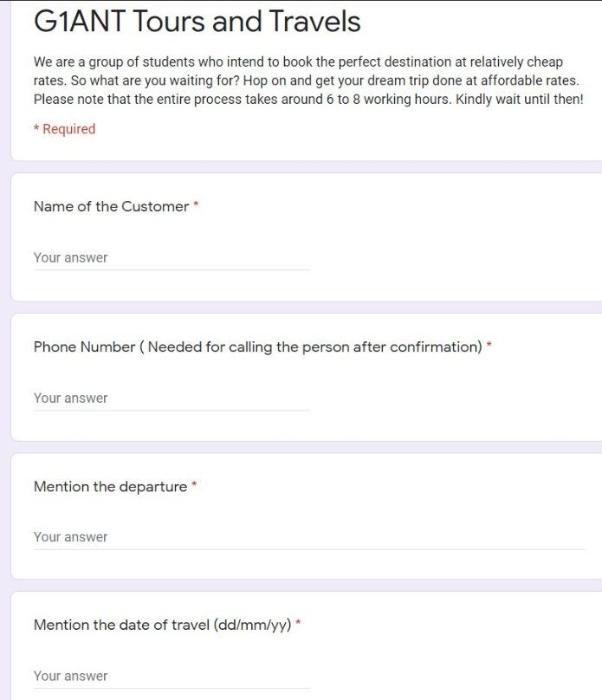GOOGLE DOCUMENT WHICH WILL COLLECT THE DATA OF CUSTOMER AND THEN PASS THIS DATA TO ROBOT

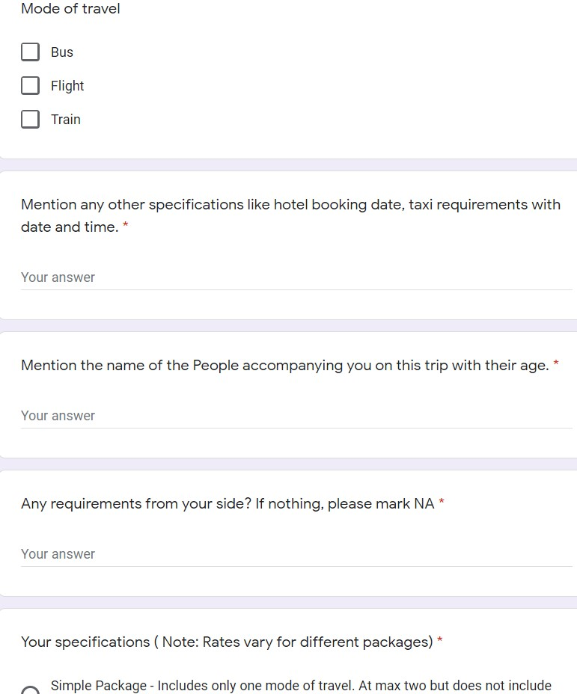

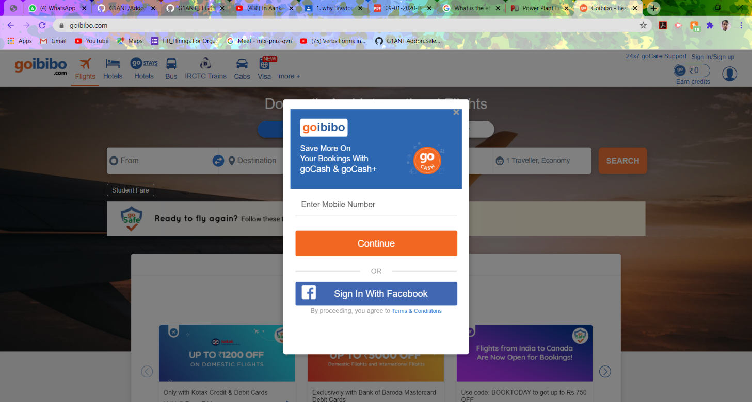 GOIBIBO LOGIN

1. FLIGHT BOOKING

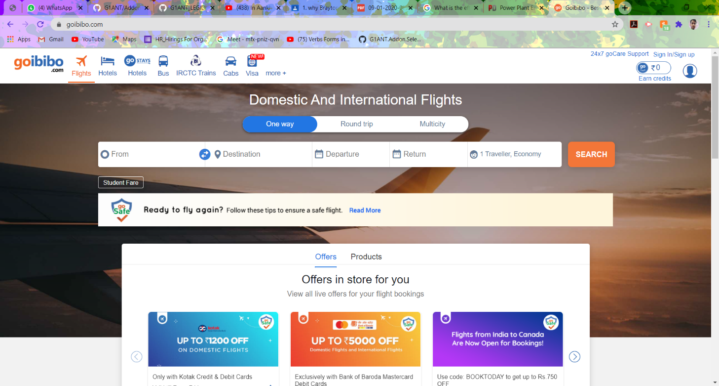

CODE IS AS FOLLOWS:

addon python version 4.1.0.0

addon appium version 4.105.0.0

addon xlsx version 4.104.0.0

addon selenium version 4.104.0.0

addon net version 4.104.0.0

addon core version 4.107.0.0

addon Goibibo version 4.106.1.0

Goibibo.open chrome url goibibo.com

delay 10

window ✱Google✱ style maximize

delay 10

Goibibo.click search get_sign_in by id

delay 2

Goibibo.click search form-control by id

♥Mobailnumber = ♥credential⟦Goibibo:Mobailnumber⟧

Goibibo.type ♥Mobailnumber search mobileSubmitBtn by id

delay 5

Goibibo.click search mobileSubmitBtn by id

Goibibo.waitforvalue ‴return document.getElementByClassName(inputSrch).length >0‴ expectedvalue true

-Enter the code send on mobaile

Goibibo.click search //*[@id="authOtpSubmitBtn"] by xpath

delay 5

-Search for flight

Goibibo.click search //*[@id="header"]/div[1]/ul/li[1]/a/span by xpath

Goibibo.waitforvalue ‴return document.getElementByClassName(inputSrch).length >0‴ expectedvalue true

♥path = ‴♥environment⟦USERPROFILE⟧\Desktop\Date of flight\flight.xlsx‴

⊂

System.IO.Directory.CreateDirectory(System.IO.Path.GetDirectoryName(♥path));

⊃

xlsx.open ♥path createifnotexist true

♥header = From❚Destination❚Departure❚Return❚Travellernoumber

call FileExcel list ♥header

Goibibo.runscript ‴return document.getElementByClassName(inputSrch).length‴ ♥websiteRecordNumber

♥websiteRecordNumber =⟦integer⟧♥websiteRecordNumber

♥i = 1

♥excelRowNumber = 1

while ⊂♥i < ♥websiteRecordNumber && ♥excelRowNumber <=15⊃

Goibibo.gettext search //*[@id="gosuggest_inputSrc"] by xpath result ♥from

Goibibo.gettext search //*[@id="gosuggest_inputDest"] by xpath result ♥destination

if⊂!♥from.contain(‴N>A‴) && !♥destination.contain(‴N>A‴)⊃

♥from = ⟦float⟧♥from

♥destination = ⟦float⟧♥destination

if⊂♥from >3 && ♥destination >30⊃

Goibibo.gettext search //*[@id="departureCalendar"] by xpath result ♥Departure

list.create ‴♥excelRowNumber♥from❚♥destination❚♥Departure❚⊂{♥from*0.05+♥destination}⊃‴ type text result ♥rowvalue

call FillExcel rownumber⊂♥excelRowNumber+1⊃ list ♥rowvalue

end if

end if

♥i = ♥i + 1

end while

xlsx.close

Goibibo.close

procedure FillExcel rownumber 1 list ⟦list:text⟧a❚b❚c

for ♥j from 1 to ⊂♥list.count⊃

xlsx.setvalue value ♥list⟦♥j⟧ row ♥rownumber colindex ♥j

end for

end procedure

Goibibo.click //*[@id="gi_search_btn"] by xpath

Goibibo.waitforvalue ‴return document.getElementByClassName(//*[@id="content"]/div/div[2]/div/div[2]/div[2]/div[2]/div[2]/div[1]/div/div[2]/span[2]/span/input).length >0‴ expectedvalue true

Goibibo.click //*[@id="content"]/div/div[2]/div/div[2]/div[2]/div[2]/div[2]/div[1]/div/div[2]/span[2]/span/input by xpath

♥path = ‴♥environment⟦USERPROFILE⟧\Desktop\travel\TravellData.xlsx‴

⊂

System.IO.Directory.CreateDirectory(System.IO.Path.GetDirectoryName(♥path));

⊃

xlsx.open ♥path createifnotexist true

♥header = name❚title❚email❚mobailnumber

call FileExcel list ♥header

Goibibo.runscript ‴return document.getElementByClassName(inputSrch).length‴ ♥websiteRecordNumber

♥websiteRecordNumber =⟦integer⟧♥websiteRecordNumber

♥i = 1

♥excelRowNumber = 1

while ⊂♥i < ♥websiteRecordNumber && ♥excelRowNumber <=15⊃

Goibibo.gettext search //*[@id="AdultfirstName1"] by xpath result ♥name

Goibibo.gettext search //*[@id="AdultlastName1"] result ♥title

if⊂!♥name.contain(‴N>A‴) && !♥title.contain(‴N>A‴)⊃

♥name = ⟦float⟧♥name

♥title = ⟦float⟧♥title

if⊂♥name>3 && ♥title >30⊃

Goibibo.gettext search //*[@id="email"] by xpath result ♥Email

list.create ‴♥excelRowNumber♥name❚♥title❚♥Email❚⊂{♥from*0.05+♥destination}⊃‴ type text result ♥rowvalue

call FillExcel rownumber⊂♥excelRowNumber+1⊃ list ♥rowvalue

end if

end if

♥i = ♥i + 1

end while

xlsx.close

Goibibo.close

procedure FillExcel rownumber 1 list ⟦list:text⟧a❚b❚c

for ♥j from 1 to ⊂♥list.count⊃

xlsx.setvalue value ♥list⟦♥j⟧ row ♥rownumber colindex ♥j

end for

end procedure

Goibibo.click //*[@id="travellerForm"]/div[2]/button/div by xpath

list.create text ♥path result ♥attachments

mail.smtp host ♥credential⟦mail:host⟧ login ♥credential⟦mail:address⟧ password ♥credential⟦mail:password⟧ from ♥credential⟦mail:address⟧ to ‴sanskarguptabaisali@gmail.com‴ subject ‴Flight Booking Information‴ body ‴Here is the booking Details‴ attachments ♥attachments

1. 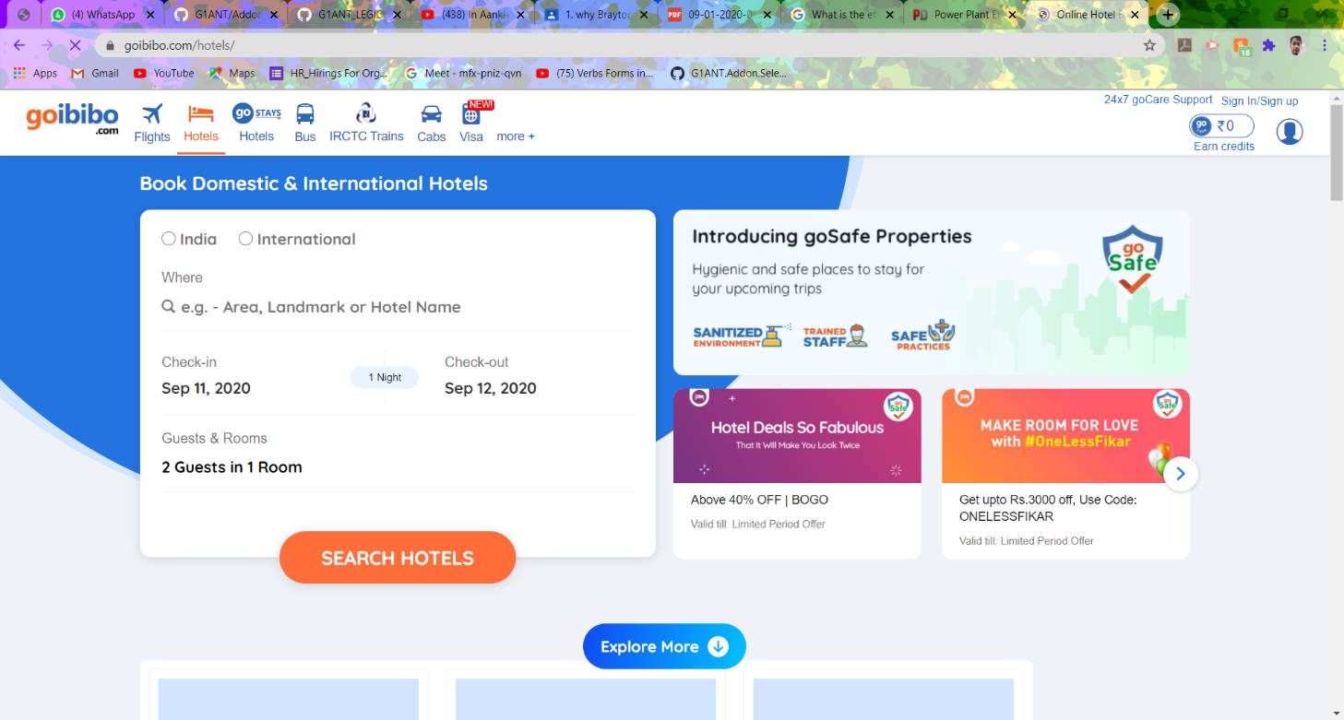HOTELS BOOKING:

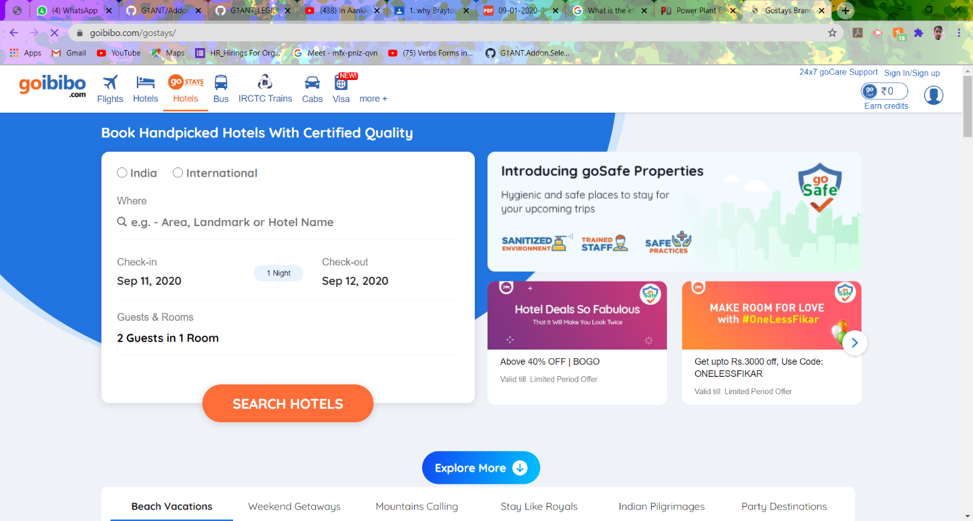

CODE IS AS FOLLOWS:

addon python version 4.1.0.0

addon appium version 4.105.0.0

addon addon version 1.0.0.0

addon xlsx version 4.104.0.0

addon selenium version 4.104.0.0

addon net version 4.104.0.0

addon core version 4.107.0.0

addon Goibibo version 4.106.1.0

Goibibo.click search get_sign_in by id

delay 2

Goibibo.click search form-control by id

♥Mobailnumber = ♥credential⟦Goibibo:Mobailnumber⟧

Goibibo.type ♥Mobailnumber search mobileSubmitBtn by id

delay 5

Goibibo.click search mobileSubmitBtn by id

Goibibo.waitforvalue ‴return document.getElementByClassName(inputSrch).length >0‴ expectedvalue true

-Enter the code send on mobaile

Goibibo.click search //*[@id="authOtpSubmitBtn"] by xpath

delay 5

-Search for hotel

Goibibo.click search //*[@id="header"]/div[1]/ul/li[2]/a/span by xpath

Goibibo.waitforvalue ‴return document.getElementByClassName(inputSrch).length >0‴ expectedvalue true

♥path = ‴♥environment⟦USERPROFILE⟧\Desktop\Date of flight\flight.xlsx‴

⊂

System.IO.Directory.CreateDirectory(System.IO.Path.GetDirectoryName(♥path));

⊃

xlsx.open ♥path createifnotexist true

♥header = From❚Destination❚Departure❚Return❚Travellernoumber

call FileExcel list ♥header

Goibibo.runscript ‴return document.getElementByClassName(inputSrch).length‴ ♥websiteRecordNumber

♥websiteRecordNumber =⟦integer⟧♥websiteRecordNumber

♥i = 1

♥excelRowNumber = 1

while ⊂♥i < ♥websiteRecordNumber && ♥excelRowNumber <=15⊃

Goibibo.gettext search //*[@id="gosuggest_inputSrc"] by xpath result ♥from

Goibibo.gettext search //*[@id="gosuggest_inputDest"] by xpath result ♥destination

if⊂!♥from.contain(‴N>A‴) && !♥destination.contain(‴N>A‴)⊃

♥from = ⟦float⟧♥from

♥destination = ⟦float⟧♥destination

if⊂♥from >3 && ♥destination >30⊃

Goibibo.gettext search //*[@id="departureCalendar"] by xpath result ♥Departure

list.create ‴♥excelRowNumber♥from❚♥destination❚♥Departure❚⊂{♥from*0.05+♥destination}⊃‴ type text result ♥rowvalue

call FillExcel rownumber⊂♥excelRowNumber+1⊃ list ♥rowvalue

end if

end if

♥i = ♥i + 1

end while

xlsx.close

Goibibo.close

procedure FillExcel rownumber 1 list ⟦list:text⟧a❚b❚c

for ♥j from 1 to ⊂♥list.count⊃

xlsx.setvalue value ♥list⟦♥j⟧ row ♥rownumber colindex ♥j

end for

end procedure

Goibibo.click //*[@id="gi_search_btn"] by xpath

Goibibo.waitforvalue ‴return document.getElementByClassName(//*[@id="content"]/div/div[2]/div/div[2]/div[2]/div[2]/div[2]/div[1]/div/div[2]/span[2]/span/input).length >0‴ expectedvalue true

Goibibo.click //*[@id="content"]/div/div[2]/div/div[2]/div[2]/div[2]/div[2]/div[1]/div/div[2]/span[2]/span/input by xpath

♥path = ‴♥environment⟦USERPROFILE⟧\Desktop\travel\TravellData.xlsx‴

⊂

System.IO.Directory.CreateDirectory(System.IO.Path.GetDirectoryName(♥path));

⊃

xlsx.open ♥path createifnotexist true

♥header = name❚title❚email❚mobailnumber

call FileExcel list ♥header

Goibibo.runscript ‴return document.getElementByClassName(inputSrch).length‴ ♥websiteRecordNumber

♥websiteRecordNumber =⟦integer⟧♥websiteRecordNumber

♥i = 1

♥excelRowNumber = 1

while ⊂♥i < ♥websiteRecordNumber && ♥excelRowNumber <=15⊃

Goibibo.gettext search //*[@id="AdultfirstName1"] by xpath result ♥name

Goibibo.gettext search //*[@id="AdultlastName1"] result ♥title

if⊂!♥name.contain(‴N>A‴) && !♥title.contain(‴N>A‴)⊃

♥name = ⟦float⟧♥name

♥title = ⟦float⟧♥title

if⊂♥name>3 && ♥title >30⊃

Goibibo.gettext search //*[@id="email"] by xpath result ♥Email

list.create ‴♥excelRowNumber♥name❚♥title❚♥Email❚⊂{♥from*0.05+♥destination}⊃‴ type text result ♥rowvalue

call FillExcel rownumber⊂♥excelRowNumber+1⊃ list ♥rowvalue

end if

end if

♥i = ♥i + 1

end while

xlsx.close

Goibibo.close

procedure FillExcel rownumber 1 list ⟦list:text⟧a❚b❚c

for ♥j from 1 to ⊂♥list.count⊃

xlsx.setvalue value ♥list⟦♥j⟧ row ♥rownumber colindex ♥j

end for

end procedure

Goibibo.click //*[@id="travellerForm"]/div[2]/button/div by xpath

list.create text ♥path result ♥attachments

mail.smtp host ♥credential⟦mail:host⟧ login ♥credential⟦mail:address⟧ password ♥credential⟦mail:password⟧ from ♥credential⟦mail:address⟧ to ‴sanskarguptabaisali@gmail.com‴ subject ‴HOTEL Booking Information‴ body ‴Here is the booking Details‴ attachments ♥attachments

1. 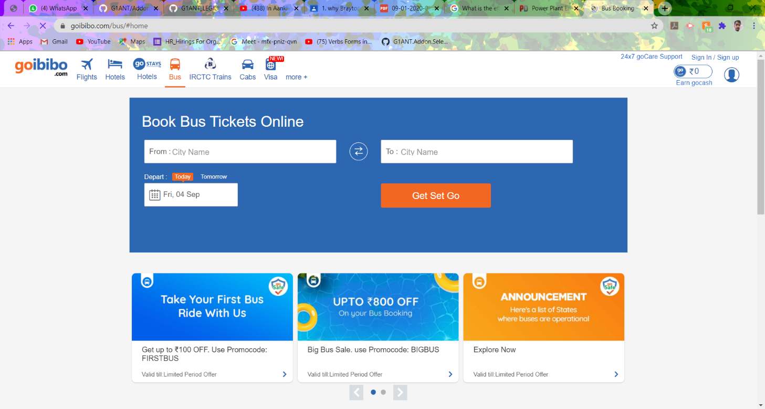BUS BOOKING:

CODE IS AS FOLLOWS:

addon python version 4.1.0.0

addon appium version 4.105.0.0

addon addon version 1.0.0.0

addon xlsx version 4.104.0.0

addon selenium version 4.104.0.0

addon net version 4.104.0.0

addon msoffice version 4.104.0.0

addon core version 4.107.0.0

addon GOIBIBO version 4.106.1.0

Goibibo.click search get_sign_in by id

delay 2

Goibibo.click search form-control by id

♥Mobailnumber = ♥credential⟦Goibibo:Mobailnumber⟧

Goibibo.type ♥Mobailnumber search mobileSubmitBtn by id

delay 5

Goibibo.click search mobileSubmitBtn by id

Goibibo.waitforvalue ‴return document.getElementByClassName(inputSrch).length >0‴ expectedvalue true

-Enter the code send on mobaile

Goibibo.click search //*[@id="authOtpSubmitBtn"] by xpath

delay 5

-Search for Bus

Goibibo.click search //*[@id="header"]/div[1]/ul/li[4]/a/i by xpath

Goibibo.waitforvalue ‴return document.getElementByClassName(inputSrch).length >0‴ expectedvalue true

♥path = ‴♥environment⟦USERPROFILE⟧\Desktop\Date of flight\flight.xlsx‴

⊂

System.IO.Directory.CreateDirectory(System.IO.Path.GetDirectoryName(♥path));

⊃

xlsx.open ♥path createifnotexist true

♥header = From❚Destination❚Departure❚Return❚Travellernoumber

call FileExcel list ♥header

Goibibo.runscript ‴return document.getElementByClassName(inputSrch).length‴ ♥websiteRecordNumber

♥websiteRecordNumber =⟦integer⟧♥websiteRecordNumber

♥i = 1

♥excelRowNumber = 1

while ⊂♥i < ♥websiteRecordNumber && ♥excelRowNumber <=15⊃

Goibibo.gettext search //*[@id="gosuggest_inputSrc"] by xpath result ♥from

Goibibo.gettext search //*[@id="gosuggest_inputDest"] by xpath result ♥destination

if⊂!♥from.contain(‴N>A‴) && !♥destination.contain(‴N>A‴)⊃

♥from = ⟦float⟧♥from

♥destination = ⟦float⟧♥destination

if⊂♥from >3 && ♥destination >30⊃

Goibibo.gettext search //*[@id="departureCalendar"] by xpath result ♥Departure

list.create ‴♥excelRowNumber♥from❚♥destination❚♥Departure❚⊂{♥from*0.05+♥destination}⊃‴ type text result ♥rowvalue

call FillExcel rownumber⊂♥excelRowNumber+1⊃ list ♥rowvalue

end if

end if

♥i = ♥i + 1

end while

xlsx.close

Goibibo.close

procedure FillExcel rownumber 1 list ⟦list:text⟧a❚b❚c

for ♥j from 1 to ⊂♥list.count⊃

xlsx.setvalue value ♥list⟦♥j⟧ row ♥rownumber colindex ♥j

end for

end procedure

Goibibo.click //*[@id="gi_search_btn"] by xpath

Goibibo.waitforvalue ‴return document.getElementByClassName(//*[@id="content"]/div/div[2]/div/div[2]/div[2]/div[2]/div[2]/div[1]/div/div[2]/span[2]/span/input).length >0‴ expectedvalue true

Goibibo.click //*[@id="content"]/div/div[2]/div/div[2]/div[2]/div[2]/div[2]/div[1]/div/div[2]/span[2]/span/input by xpath

♥path = ‴♥environment⟦USERPROFILE⟧\Desktop\travel\TravellData.xlsx‴

⊂

System.IO.Directory.CreateDirectory(System.IO.Path.GetDirectoryName(♥path));

⊃

xlsx.open ♥path createifnotexist true

♥header = name❚title❚email❚mobailnumber

call FileExcel list ♥header

Goibibo.runscript ‴return document.getElementByClassName(inputSrch).length‴ ♥websiteRecordNumber

♥websiteRecordNumber =⟦integer⟧♥websiteRecordNumber

♥i = 1

♥excelRowNumber = 1

while ⊂♥i < ♥websiteRecordNumber && ♥excelRowNumber <=15⊃

Goibibo.gettext search //*[@id="AdultfirstName1"] by xpath result ♥name

Goibibo.gettext search //*[@id="AdultlastName1"] result ♥title

if⊂!♥name.contain(‴N>A‴) && !♥title.contain(‴N>A‴)⊃

♥name = ⟦float⟧♥name

♥title = ⟦float⟧♥title

if⊂♥name>3 && ♥title >30⊃

Goibibo.gettext search //*[@id="email"] by xpath result ♥Email

list.create ‴♥excelRowNumber♥name❚♥title❚♥Email❚⊂{♥from*0.05+♥destination}⊃‴ type text result ♥rowvalue

call FillExcel rownumber⊂♥excelRowNumber+1⊃ list ♥rowvalue

end if

end if

♥i = ♥i + 1

end while

xlsx.close

Goibibo.close

procedure FillExcel rownumber 1 list ⟦list:text⟧a❚b❚c

for ♥j from 1 to ⊂♥list.count⊃

xlsx.setvalue value ♥list⟦♥j⟧ row ♥rownumber colindex ♥j

end for

end procedure

Goibibo.click //*[@id="travellerForm"]/div[2]/button/div by xpath

list.create text ♥path result ♥attachments

mail.smtp host ♥credential⟦mail:host⟧ login ♥credential⟦mail:address⟧ password ♥credential⟦mail:password⟧ from ♥credential⟦mail:address⟧ to ‴sanskarguptabaisali@gmail.com‴ subject ‴HOTEL Booking Information‴ body ‴Here is the booking Details‴ attachments ♥attachments

1. TRAIN BOOKING:

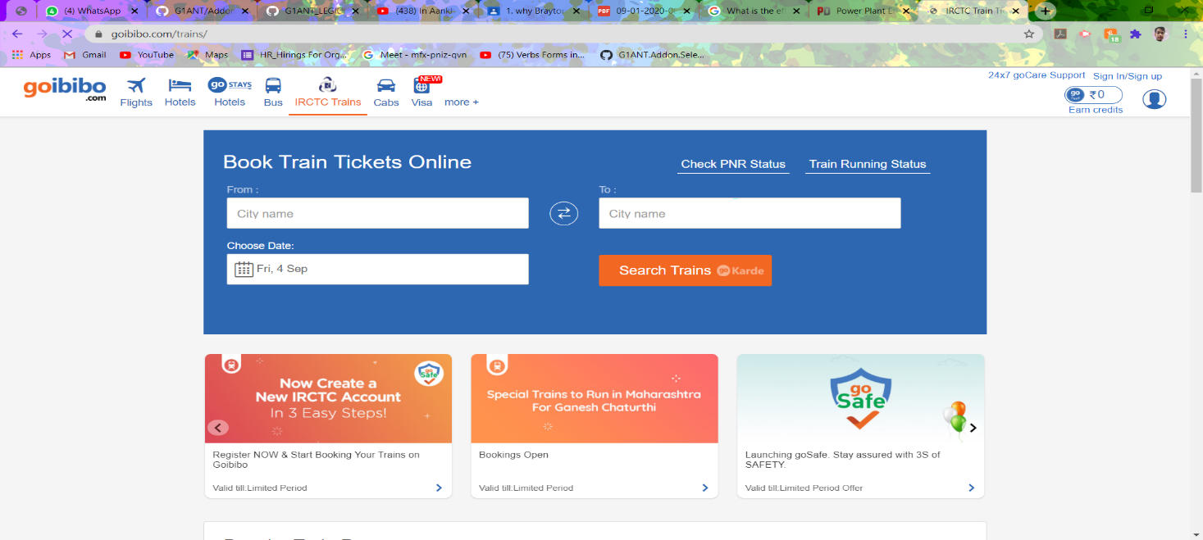

CODE IS AS FOLLOWS:

addon appium version 4.105.0.0

addon addon version 1.0.0.0

addon xlsx version 4.104.0.0

addon selenium version 4.104.0.0

addon net version 4.104.0.0

addon msoffice version 4.104.0.0

addon iexplorer version 4.104.0.0

addon core version 4.107.0.0

addon Goibibo version 4.106.1.0

Goibibo.click search get_sign_in by id

delay 2

Goibibo.click search form-control by id

♥Mobailnumber = ♥credential⟦Goibibo:Mobailnumber⟧

Goibibo.type ♥Mobailnumber search mobileSubmitBtn by id

delay 5

Goibibo.click search mobileSubmitBtn by id

Goibibo.waitforvalue ‴return document.getElementByClassName(inputSrch).length >0‴ expectedvalue true

-Enter the code send on mobaile

Goibibo.click search //*[@id="authOtpSubmitBtn"] by xpath

delay 5

-Search for Train

Goibibo.click search //*[@id="header"]/div[1]/ul/li[2]/a/span by xpath

Goibibo.waitforvalue ‴return document.getElementByClassName(inputSrch).length >0‴ expectedvalue true

♥path = ‴♥environment⟦USERPROFILE⟧\Desktop\Date of flight\flight.xlsx‴

⊂

System.IO.Directory.CreateDirectory(System.IO.Path.GetDirectoryName(♥path));

⊃

xlsx.open ♥path createifnotexist true

♥header = From❚Destination❚Departure❚Return❚Travellernoumber

call FileExcel list ♥header

Goibibo.runscript ‴return document.getElementByClassName(inputSrch).length‴ ♥websiteRecordNumber

♥websiteRecordNumber =⟦integer⟧♥websiteRecordNumber

♥i = 1

♥excelRowNumber = 1

while ⊂♥i < ♥websiteRecordNumber && ♥excelRowNumber <=15⊃

Goibibo.gettext search //*[@id="gosuggest_inputSrc"] by xpath result ♥from

Goibibo.gettext search //*[@id="gosuggest_inputDest"] by xpath result ♥destination

if⊂!♥from.contain(‴N>A‴) && !♥destination.contain(‴N>A‴)⊃

♥from = ⟦float⟧♥from

♥destination = ⟦float⟧♥destination

if⊂♥from >3 && ♥destination >30⊃

Goibibo.gettext search //*[@id="departureCalendar"] by xpath result ♥Departure

list.create ‴♥excelRowNumber♥from❚♥destination❚♥Departure❚⊂{♥from*0.05+♥destination}⊃‴ type text result ♥rowvalue

call FillExcel rownumber⊂♥excelRowNumber+1⊃ list ♥rowvalue

end if

end if

♥i = ♥i + 1

end while

xlsx.close

Goibibo.close

procedure FillExcel rownumber 1 list ⟦list:text⟧a❚b❚c

for ♥j from 1 to ⊂♥list.count⊃

xlsx.setvalue value ♥list⟦♥j⟧ row ♥rownumber colindex ♥j

end for

end procedure

Goibibo.click //*[@id="gi_search_btn"] by xpath

Goibibo.waitforvalue ‴return document.getElementByClassName(//*[@id="content"]/div/div[2]/div/div[2]/div[2]/div[2]/div[2]/div[1]/div/div[2]/span[2]/span/input).length >0‴ expectedvalue true

Goibibo.click //*[@id="content"]/div/div[2]/div/div[2]/div[2]/div[2]/div[2]/div[1]/div/div[2]/span[2]/span/input by xpath

♥path = ‴♥environment⟦USERPROFILE⟧\Desktop\travel\TravellData.xlsx‴

⊂

System.IO.Directory.CreateDirectory(System.IO.Path.GetDirectoryName(♥path));

⊃

xlsx.open ♥path createifnotexist true

♥header = name❚title❚email❚mobailnumber

call FileExcel list ♥header

Goibibo.runscript ‴return document.getElementByClassName(inputSrch).length‴ ♥websiteRecordNumber

♥websiteRecordNumber =⟦integer⟧♥websiteRecordNumber

♥i = 1

♥excelRowNumber = 1

while ⊂♥i < ♥websiteRecordNumber && ♥excelRowNumber <=15⊃

Goibibo.gettext search //*[@id="AdultfirstName1"] by xpath result ♥name

Goibibo.gettext search //*[@id="AdultlastName1"] result ♥title

if⊂!♥name.contain(‴N>A‴) && !♥title.contain(‴N>A‴)⊃

♥name = ⟦float⟧♥name

♥title = ⟦float⟧♥title

if⊂♥name>3 && ♥title >30⊃

Goibibo.gettext search //*[@id="email"] by xpath result ♥Email

list.create ‴♥excelRowNumber♥name❚♥title❚♥Email❚⊂{♥from*0.05+♥destination}⊃‴ type text result ♥rowvalue

call FillExcel rownumber⊂♥excelRowNumber+1⊃ list ♥rowvalue

end if

end if

♥i = ♥i + 1

end while

xlsx.close

Goibibo.close

procedure FillExcel rownumber 1 list ⟦list:text⟧a❚b❚c

for ♥j from 1 to ⊂♥list.count⊃

xlsx.setvalue value ♥list⟦♥j⟧ row ♥rownumber colindex ♥j

end for

end procedure

Goibibo.click //*[@id="travellerForm"]/div[2]/button/div by xpath

list.create text ♥path result ♥attachments

mail.smtp host ♥credential⟦mail:host⟧ login ♥credential⟦mail:address⟧ password ♥credential⟦mail:password⟧ from ♥credential⟦mail:address⟧ to ‴sanskarguptabaisali@gmail.com‴ subject ‴TRAIN Booking Information‴ body ‴Here is the booking Details‴ attachments ♥attachmentsaddon python version 4.1.0.0

1. CAB BOOKING:

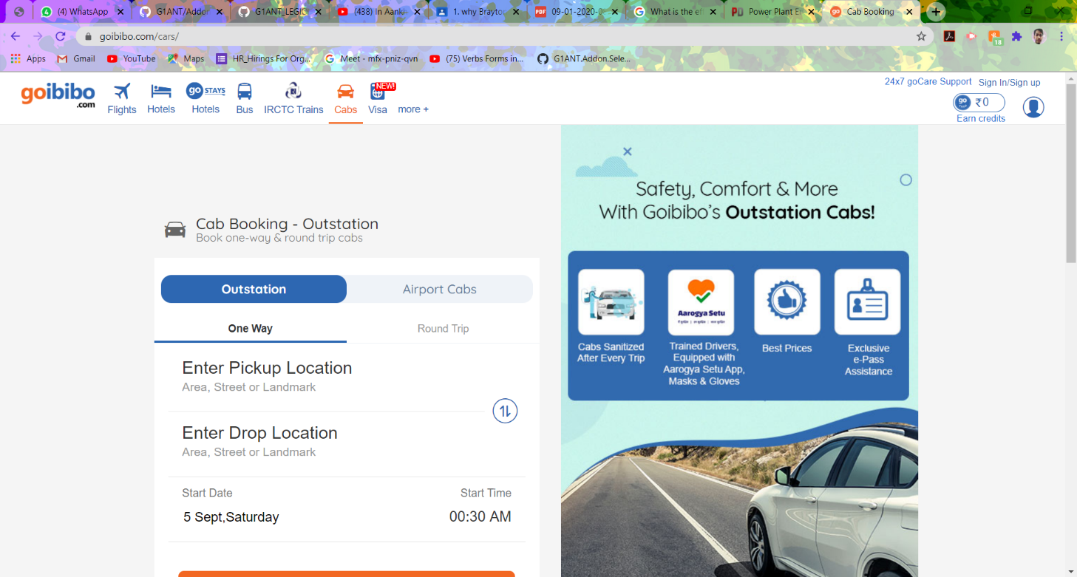

CODE IS AS FOLLOWS:

addon python version 4.1.0.0

addon appium version 4.105.0.0

addon addon version 1.0.0.0

addon xlsx version 4.104.0.0

addon selenium version 4.104.0.0

addon net version 4.104.0.0

addon core version 4.107.0.0

addon Goibibo version 4.106.1.0

Goibibo.click search get_sign_in by id

delay 2

Goibibo.click search form-control by id

♥Mobailnumber = ♥credential⟦Goibibo:Mobailnumber⟧

Goibibo.type ♥Mobailnumber search mobileSubmitBtn by id

delay 5

Goibibo.click search mobileSubmitBtn by id

Goibibo.waitforvalue ‴return document.getElementByClassName(inputSrch).length >0‴ expectedvalue true

-Enter the code send on mobaile

Goibibo.click search //*[@id="authOtpSubmitBtn"] by xpath

delay 5

-Search for Cab

Goibibo.click search //*[@id="header"]/div[1]/ul/li[6]/a/i by xpath

Goibibo.waitforvalue ‴return document.getElementByClassName(inputSrch).length >0‴ expectedvalue true

♥path = ‴♥environment⟦USERPROFILE⟧\Desktop\Date of flight\flight.xlsx‴

⊂

System.IO.Directory.CreateDirectory(System.IO.Path.GetDirectoryName(♥path));

⊃

xlsx.open ♥path createifnotexist true

♥header = From❚Destination❚Departure❚Return❚Travellernoumber

call FileExcel list ♥header

Goibibo.runscript ‴return document.getElementByClassName(inputSrch).length‴ ♥websiteRecordNumber

♥websiteRecordNumber =⟦integer⟧♥websiteRecordNumber

♥i = 1

♥excelRowNumber = 1

while ⊂♥i < ♥websiteRecordNumber && ♥excelRowNumber <=15⊃

Goibibo.gettext search //*[@id="gosuggest_inputSrc"] by xpath result ♥from

Goibibo.gettext search //*[@id="gosuggest_inputDest"] by xpath result ♥destination

if⊂!♥from.contain(‴N>A‴) && !♥destination.contain(‴N>A‴)⊃

♥from = ⟦float⟧♥from

♥destination = ⟦float⟧♥destination

if⊂♥from >3 && ♥destination >30⊃

Goibibo.gettext search //*[@id="departureCalendar"] by xpath result ♥Departure

list.create ‴♥excelRowNumber♥from❚♥destination❚♥Departure❚⊂{♥from*0.05+♥destination}⊃‴ type text result ♥rowvalue

call FillExcel rownumber⊂♥excelRowNumber+1⊃ list ♥rowvalue

end if

end if

♥i = ♥i + 1

end while

xlsx.close

Goibibo.close

procedure FillExcel rownumber 1 list ⟦list:text⟧a❚b❚c

for ♥j from 1 to ⊂♥list.count⊃

xlsx.setvalue value ♥list⟦♥j⟧ row ♥rownumber colindex ♥j

end for

end procedure

Goibibo.click //*[@id="gi_search_btn"] by xpath

Goibibo.waitforvalue ‴return document.getElementByClassName(//*[@id="content"]/div/div[2]/div/div[2]/div[2]/div[2]/div[2]/div[1]/div/div[2]/span[2]/span/input).length >0‴ expectedvalue true

Goibibo.click //*[@id="content"]/div/div[2]/div/div[2]/div[2]/div[2]/div[2]/div[1]/div/div[2]/span[2]/span/input by xpath

♥path = ‴♥environment⟦USERPROFILE⟧\Desktop\travel\TravellData.xlsx‴

⊂

System.IO.Directory.CreateDirectory(System.IO.Path.GetDirectoryName(♥path));

⊃

xlsx.open ♥path createifnotexist true

♥header = name❚title❚email❚mobailnumber

call FileExcel list ♥header

Goibibo.runscript ‴return document.getElementByClassName(inputSrch).length‴ ♥websiteRecordNumber

♥websiteRecordNumber =⟦integer⟧♥websiteRecordNumber

♥i = 1

♥excelRowNumber = 1

while ⊂♥i < ♥websiteRecordNumber && ♥excelRowNumber <=15⊃

Goibibo.gettext search //*[@id="AdultfirstName1"] by xpath result ♥name

Goibibo.gettext search //*[@id="AdultlastName1"] result ♥title

if⊂!♥name.contain(‴N>A‴) && !♥title.contain(‴N>A‴)⊃

♥name = ⟦float⟧♥name

♥title = ⟦float⟧♥title

if⊂♥name>3 && ♥title >30⊃

Goibibo.gettext search //*[@id="email"] by xpath result ♥Email

list.create ‴♥excelRowNumber♥name❚♥title❚♥Email❚⊂{♥from*0.05+♥destination}⊃‴ type text result ♥rowvalue

call FillExcel rownumber⊂♥excelRowNumber+1⊃ list ♥rowvalue

end if

end if

♥i = ♥i + 1

end while

xlsx.close

Goibibo.close

procedure FillExcel rownumber 1 list ⟦list:text⟧a❚b❚c

for ♥j from 1 to ⊂♥list.count⊃

xlsx.setvalue value ♥list⟦♥j⟧ row ♥rownumber colindex ♥j

end for

end procedure

Goibibo.click //*[@id="travellerForm"]/div[2]/button/div by xpath

list.create text ♥path result ♥attachments

mail.smtp host ♥credential⟦mail:host⟧ login ♥credential⟦mail:address⟧ password ♥credential⟦mail:password⟧ from ♥credential⟦mail:address⟧ to ‴sanskarguptabaisali@gmail.com‴ subject ‴CAB Booking Information‴ body ‴Here is the booking Details‴ attachments ♥attachments

PAYMENT AND BOOKING:

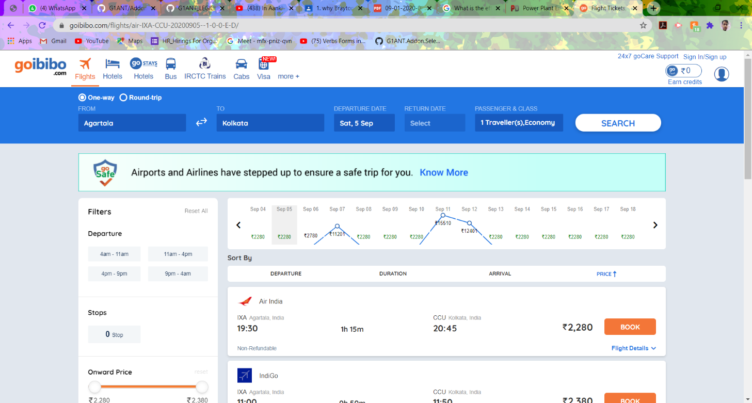

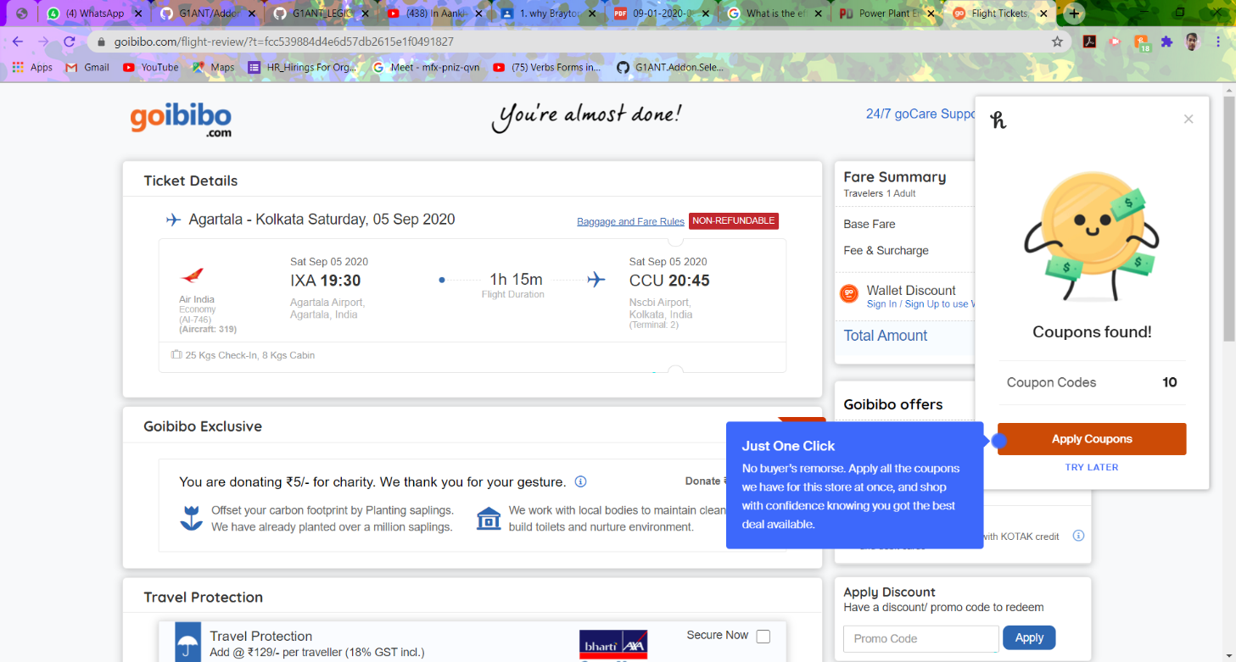

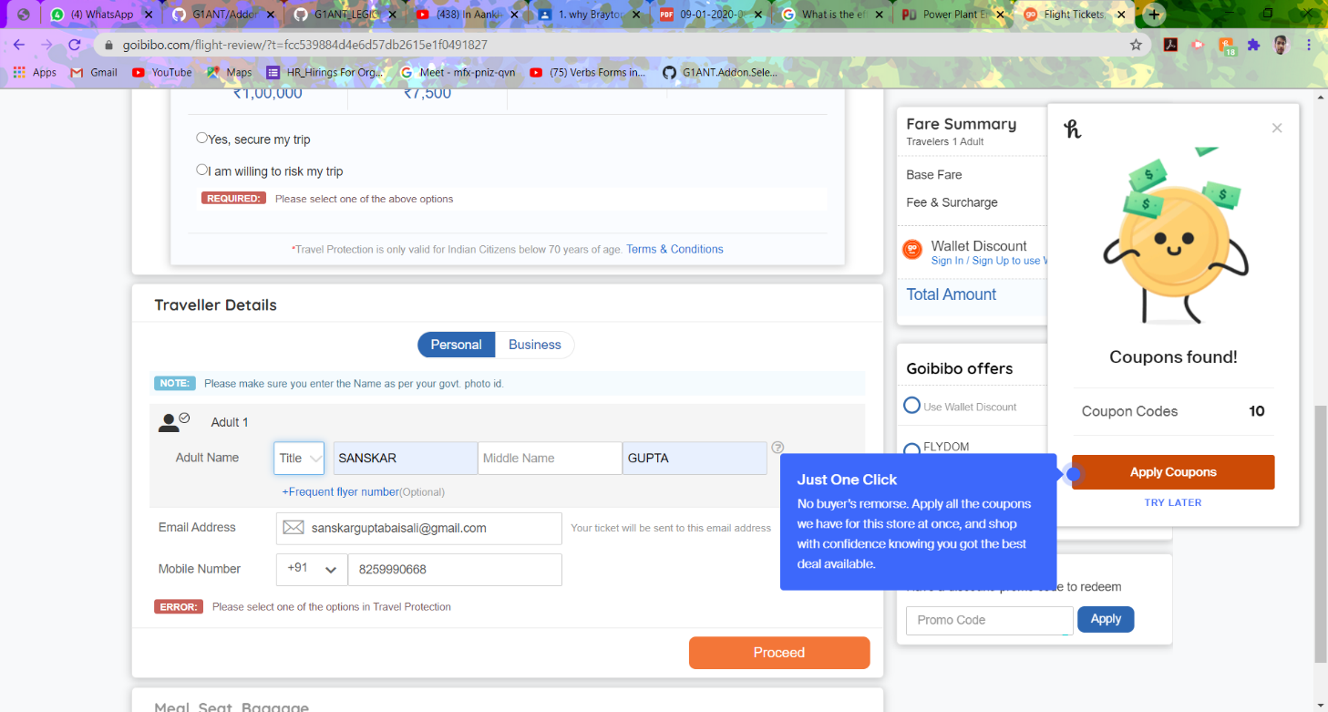

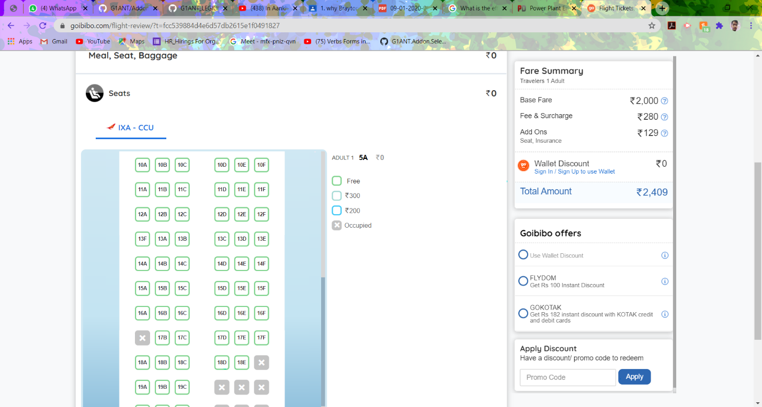

# CONFIRMATION EMAIL

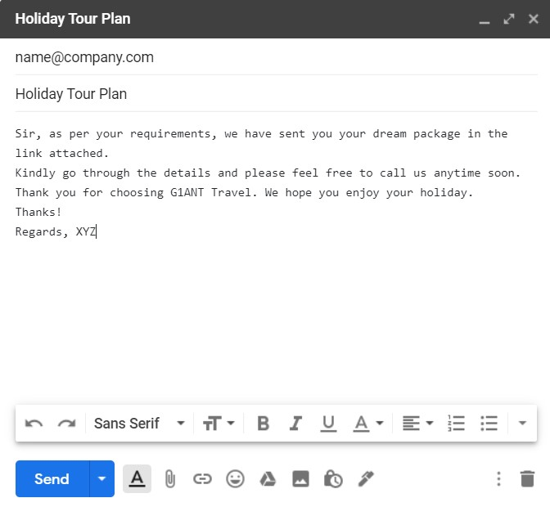

HENCE IN THIS WAY THE BOOT WILL BOOK THE TICKET.HPE YOU WILL LIKE IT.

THANK YOU